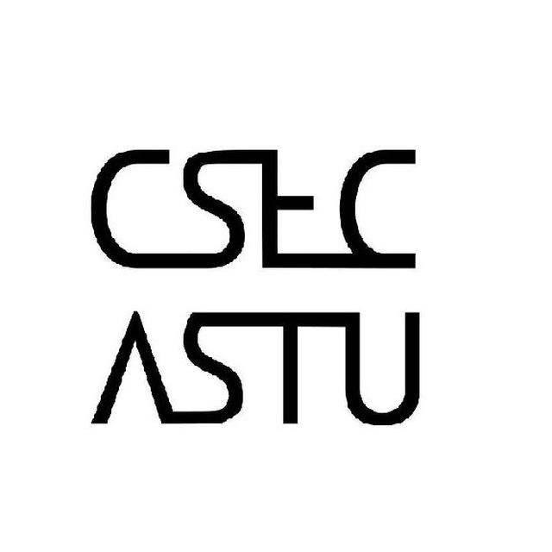 

**For all ASTU Students**

Do you have an Idea for a **CSE related project** with a team or individually? And does your project involve **hardware components**? Well you’re in luck because **CSEC is accepting proposals** for such kinds of projects. All you have to do is submit your project proposal to us for evaluation.

Submission location: B-508 R-9

Submission deadline: Saturday, Nov 24-2018 __ 12:00 Local time

Make sure you submit your proposal before the deadline…